Henry VIII was the King of England from 1509 – 1547.

First colour in the picture of Henry VIII and then around him write some ideas about what he did and said that show his thinking about the Catholic Church. *(NB. His ideas changed!)*

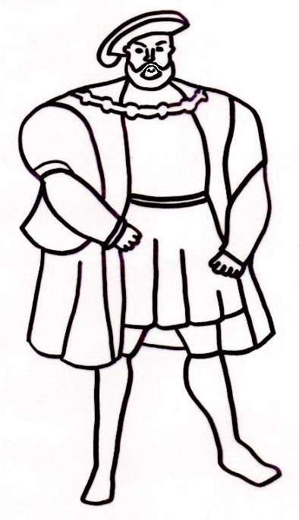

NCRS 2017