First Swedish bishop since the Reformation to be made a cardinal

by [Carol Glatz](http://www.catholicherald.co.uk/author/carol-glatz/)

posted Thursday, 25 May 2017

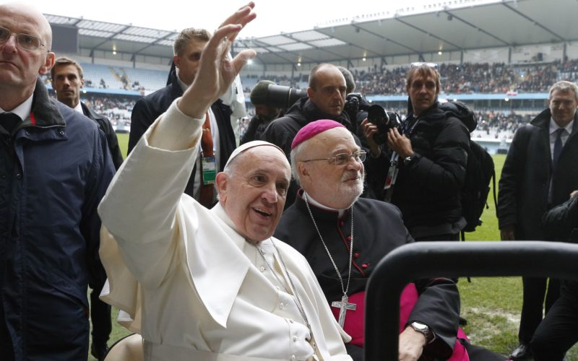

*Pope Francis and then Bishop Anders Arborelius of Stockholm ride in a golf car in Malmo, Sweden (Photo:CNS)*

*Cardinal-designate Anders Arborelius said the appointment showed that even tiny groups of Catholics were important*

Cardinal-designate Anders Arborelius of Stockholm is Sweden’s only Catholic bishop and the first native Swede to hold the post since the Protestant Reformation in the 1500s.

He was also the first Swede to be named a bishop in more than 400 years when he was named by St John Paul II to lead the country’s lone diocese in 1998.

Now, Pope Francis will make him the first cardinal in Sweden’s history when he is formally inducted into the College of Cardinals June 28 along with new cardinals from Mali, Spain, Laos and El Salvador.

“It’s really a historical event and I think it’s typical of Pope Francis that he looks to those parts of the world that are far away – other cardinals were named for the first time for Laos and for Mali – so he wants to encourage those minorities scattered all over the world and show that they are important in God’s eyes and in the eyes of the Church even if they are very small realities,” the cardinal-designate told Vatican Radio.

The Catholic Church in Sweden has had an important role in helping “integrate many refugees, and we know that this is a very important issue for the pope, and we also have a very broad ecumenical dialogue with all the Christian churches,” he told the radio.

However, it still was “a real surprise that the Holy Father has chosen me,” said the 67-year-old prelate, and Catholics in Sweden are “very happy about it.”

The Pope sees having a cardinal in Sweden as a way to encourage its “very important mission” as a small minority in one of the most secular countries in Europe, he said. In surveys, less than a third of Swedes describe themselves as religious and even fewer participate regularly in church services.

However, “even in the secular society, there are certain Christian values that are very much alive – this wish to help poor people, to protect those who are in danger and to establish equal rights for everyone,” the cardinal-designate told Catholic News Service ahead of Pope Francis’ visit to Sweden in 2016. Cardinal-designate Arborelius hosted the Pope’s visit as part of an ecumenical commemoration of the 500th anniversary of the Protestant Reformation.

More than 60 per cent of Swedes are baptised members of the Lutheran Church of Sweden and just over one per cent are registered members of the Catholic Church, although Cardinal-designate Arborelius said that with the ever-increasing number of immigrants in the country, the number of Catholics is probably double the official 115,000.

Born in Switzerland on September 24, 1949, to Swedish parents, he was raised in Sweden and converted to Catholicism at the age of 19.

He told CNS in 2016 that he had not been “very active” as a Lutheran, but that he always felt drawn to “the contemplative life or spirituality.”

“I always had this longing for a life of prayer and silent adoration.”

He said his family’s contact with the Bridgettine Sisters had a deep influence on him and eventually he began taking courses in the Catholic faith.

He entered the Discalced Carmelites just two years after becoming Catholic, took vows in 1977 and was ordained to the priesthood in 1979.

He was ordained bishop of Stockholm in 1998. He was the first Swede to lead the Church there since 1522 because a long-standing shortage of native-born priests had meant that the Pope appointed bishops from other countries like Germany and the United States.