Martin Luther 1483-1546 was a key person in the Reformation.

First colour in the picture of Martin Luther and then around him write some ideas about what he did and said that made him have difficulties/ problems with the Catholic Church.

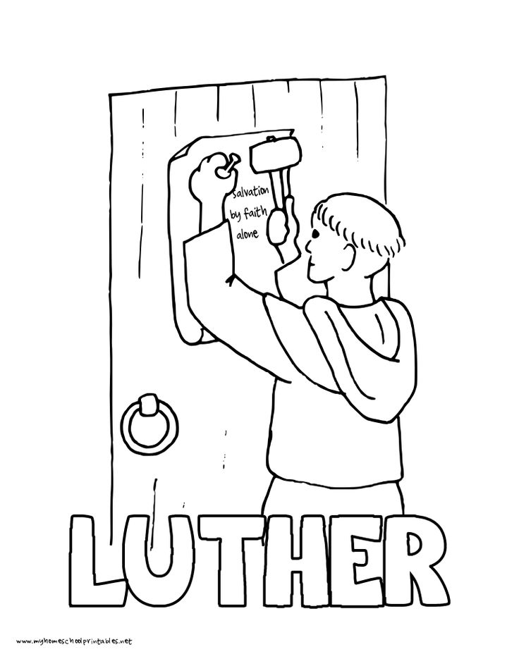

NCRS 2017