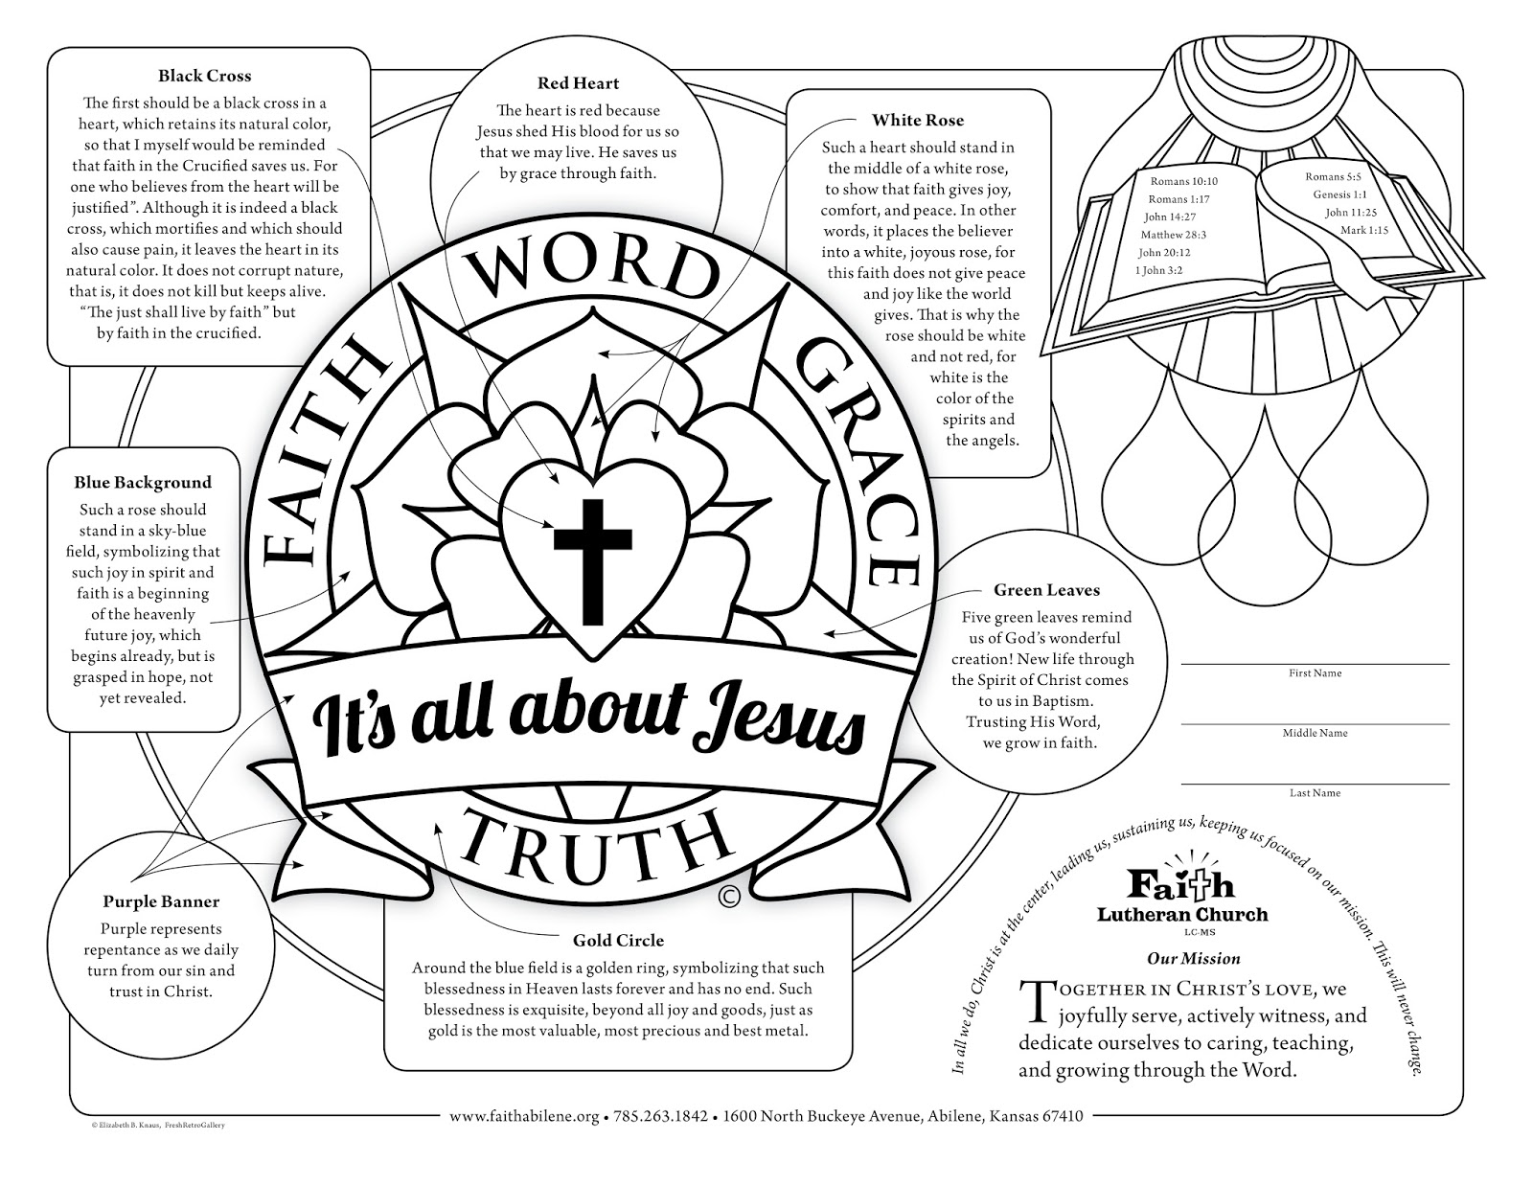 | Read the information about the Lutheran Church Rose symbol and colour it in as suggested.  NCRS 2017

