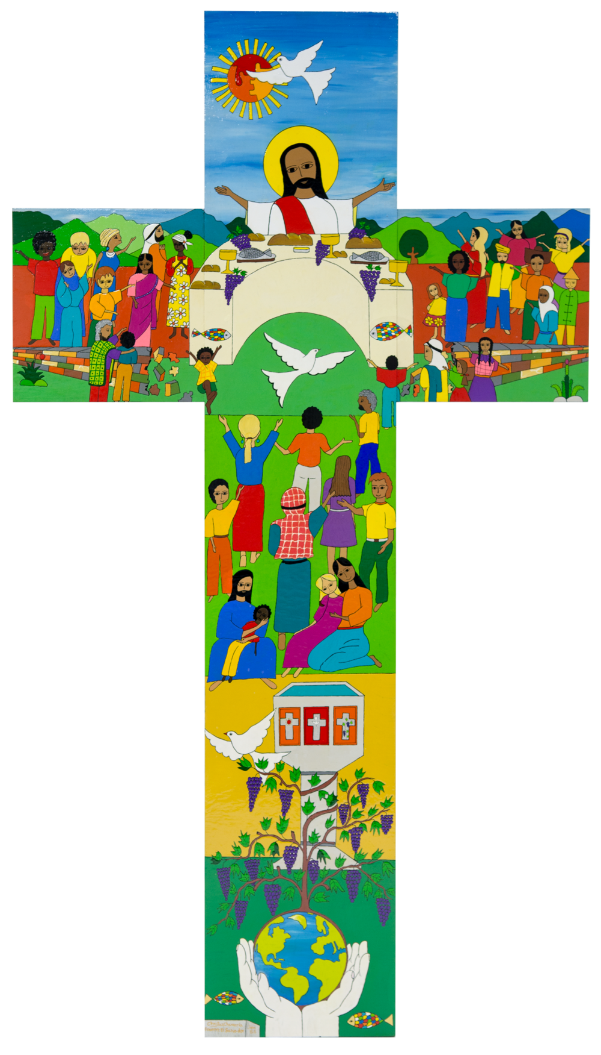

http://www.lund2016.net/

**Commemoration Prayer Service - 500 years since Martin Luther**

And a 500 year journey as Catholics and Lutherans

|  |  |
| --- | --- |
| Gathering & Welcome:  Welcome to everyone who has come together here to think about and as Catholics commemorate the Reformation or Reformations that were a series of religious, political, intellectual and cultural upheavals that split Catholic Eurpoe and began what would be the organisations, structures, ideas and thinking that mark the modern era.  This Reformations prayer is not about the religious upheaval that is generally seen as the centre of the overall process by many. This was the first major split in religious thinking within the Catholic Church since the Schism of 1054 that had seen the split the western and eastern branches of the Church.  What we will do is think about what we have that is common as Christians, rather than the difference we have in the way we practice what it means to be a Christian. So let us begin...  Image result for trinity  We gather:  **Ki to ingoa O te Matua**  **O** **te Tamaiti O te Wairua Tapu**  https://commons.wikimedia.org/wiki/File:Angelsatmamre-trinity-rublev-1410.jpg  **Amene.**  Let us think about the journey in  front of us.   * A time for prayer. * A time for thinking. * A time for learning. * A time for sharing. * https://upload.wikimedia.org/wikipedia/commons/thumb/4/43/Candle_%28Slava_celebration%29.jpg/220px-Candle_%28Slava_celebration%29.jpgA time for reflecting.   So, as we begin this time together  we light this candle in the name of  the Maker, who lit the world and  breathed the breath of life into each  one of us.  https://en.wikipedia.org/wiki/Candle#/media/File:Candle_(Slava_celebration).jpg  We light this candle in the name of  the Jesus who saved the world and  stretched out his hands for us.  We light this candle in the name of  the ruah, Spirit, who encompasses  the world and blesses our souls with  longing.    https://upload.wikimedia.org/wikipedia/commons/2/23/Paris_-_Bibl._Mazarine_-_ms._0924%2C_f_150v.jpgWe profess the Apostles Creed together:  **I believe in God, the Father almighty, Creator of heaven and earth, and in Jesus Christ, his only Son, our Lord, who was conceived by the Holy Spirit, born of the Virgin Mary, suffered under Pontius Pilate, was crucified, died and was buried;**  **He descended into hell;**  **On the third day he rose again from the dead;**  **he ascended into heaven, and is seated at the right hand of God the Father almighty;**  By Unknown - http://idlespeculations-terryprest.blogspot.com/2014/02/the-apostles-creed.html, Public Domain,  **from there he will come to judge the living and the dead.**  **I believe in the Holy Spirit,**  **the holy catholic Church,**  **the communion of saints,**  **the forgiveness of sins,**  **the resurrection of the body,**  **and life everlasting.**  **Amen.**  A reading from the holy Gospel according to John 15:1-10  1 I am the true vine, and my Father is the vinedresser. 2 Every branch in me that bears no fruit he cuts away, and every branch that does bear fruit he prunes to make it bear even more. 3 You are clean already, by means of the word that I have spoken to you. 4 Remain in me, as I in you. As a branch cannot bear fruit all by itself, unless it remains part of the vine, neither can you unless you remain in me.  5 I am the vine, you are the branches. Whoever remains in me, with me in him, bears fruit in plenty; for cut off from me you can do nothing. 6 Anyone who does not remain in me is thrown away like a branch -- and withers; these branches are collected and thrown on the fire and are burnt.  7 If you remain in me and my words remain in you, you may ask for whatever you please and you [will](http://www.catholic.org/encyclopedia/view.php?id=12332) get it.  8 It is to the [glory](http://www.catholic.org/encyclopedia/view.php?id=5201) of my Father that you should bear much fruit and be my disciples. 9 I have loved you just as the Father has loved me. Remain in my love. 10 If you keep my commandments you [will](http://www.catholic.org/encyclopedia/view.php?id=12332) remain in my love, just as I have kept my Father's commandments and remain in his love.  The Gospel of the Lord:  All: Praise to you Lord Jesus Christ | |
| Prayers of the community gathered:  We pray that the Word of God will open our hearts and bring reconciliation between all peoples.  Respond:  **E te Ariki, Whakarongo mai rā ki a mātou**  We pray that our hearts will be filled with compassion for those who have nothing.  E te Ariki Whakarongo mai rā ki a mātou  We pray with our community that we can reach out to victims of poverty, violence and injustice.  E te Ariki Whakarongo mai rā ki a mātou  http://www.trinitylutheranblair.com/about/our-pastor.html  We pray for all Christians that we work together to proclaim the glory of God.  E te Ariki Whakarongo mai rā ki a mātou  We have time now for any Prayers from those gathered here ……  E te Ariki Whakarongo mai rā ki a mātou | JesusStainGlass |
| Let us offer our commitments: Five Imperatives found in “From Conflict to Communion” will guide us.  Our ecumenical journey continues. In this worship, we commit ourselves to grow in communion. Common Commemoration of the 500th Anniversary of the Reformation  *[A large candle is lighted after each commitment is read. The light may be taken each time from the Paschal Candle. Young people may be asked to read the five commitments and the candles may be lit by children and families. The organ or other instrument may play the melody of a song such as “In the Lord I’ll be ever thankful” (Taizé) or another song to accompany the lighting of the candles.]*  1. Catholics and Lutherans should always begin from the perspective of unity and not from the point of view of division in order to strengthen what is held in common even though the differences are more easily seen and experienced. (#239)  *Light a candle*  2. Lutherans and Catholics must let themselves continuously be transformed by the encounter with the other and by the mutual witness of faith. (#240)  *Light a candle*  3. Catholics and Lutherans should again commit themselves to seek visible unity, to elaborate together what this means in concrete steps, and to strive repeatedly toward this goal. (#241)  *Light a candle*  4. Lutherans and Catholics should jointly rediscover the power of the gospel of Jesus Christ for our time. (#242)  *Light a candle*  5. Catholics and Lutherans should witness together to the mercy of God in proclamation and service to the world. (#243)  *Light a candle.* | |

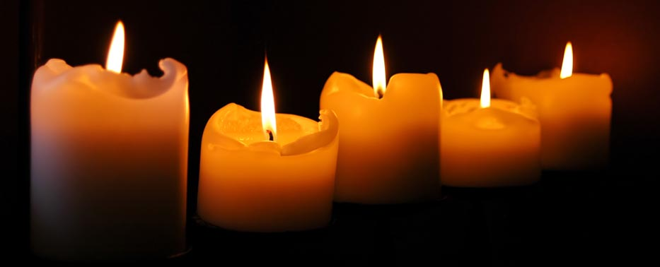

http://www.atzmut.com/candles-home/

|  |
| --- |
| Let us listen to the Homily of Pope Francis at Lund in 2016 at the start of the year of commemoration:  Abide in me as I abide in you” (Jn 15:4). These words, spoken by Jesus at the Last Supper, allow us to peer into the heart of Christ just before his ultimate sacrifice on the cross. We can feel his heart beating with love for us and his desire for the unity of all who believe in him. He tells us that he is the true vine and that we are the branches, that just as he is one with the Father, so we must be one with him if we wish to bear fruit.  Here in Lund, at this prayer service, we wish to manifest our shared desire to remain one with Christ, so that we may have life. We ask him, “Lord, help us by your grace to be more closely united to you and thus, together, to bear a more effective witness of faith, hope and love”. This is also a moment to thank God for the efforts of our many brothers and sisters from different ecclesial communities who refused to be resigned to division, but instead kept alive the hope of reconciliation among all who believe in the one Lord.  As Catholics and Lutherans, we have undertaken a common journey of reconciliation. Now, in the context of the commemoration of the Reformation of 1517, we have a new opportunity to accept a common path, one that has taken shape over the past fifty years in the ecumenical dialogue between the Lutheran World Federation and the Catholic Church. Nor can we be resigned to the division and distance that our separation has created between us. We have the opportunity to mend a critical moment of our history by moving beyond the controversies and disagreements that have often prevented us from understanding one another.  Jesus tells us that the Father is the “vinedresser” (cf. v. 1) who tends and prunes the vine in order to make it bear more fruit (cf. v. 2). The Father is constantly concerned for our relationship with Jesus, to see if we are truly one with him (cf. v. 4). He watches over us, and his gaze of love inspires us to purify our past and to work in the present to bring about the future of unity that he so greatly desires.  We too must look with love and honesty at our past, recognizing error and seeking forgiveness, for God alone is our judge. We ought to recognize with the same honesty and love that our division distanced us from the primordial intuition of God’s people, who naturally yearn to be one, and that it was perpetuated historically by the powerful of this world rather than the faithful people, which always and everywhere needs to be guided surely and lovingly by its Good Shepherd. Certainly, there was a sincere will on the part of both sides to profess and uphold the true faith, but at the same time we realize that we closed in on ourselves out of fear or bias with regard to the faith which others profess with a different accent and language. As Pope John Paul II said, “We must not allow ourselves to be guided by the intention of setting ourselves up as judges of history but solely by the motive of understanding better what happened and of becoming messengers of truth” (Letter to Cardinal Johannes Willebrands, President of the Secretariat for Christian Unity, 31 October 1983). God is the vinedresser, who with immense love tends and protects the vine; let us be moved by his watchful gaze. The one thing he desires is for us to abide like living branches in his Son Jesus. With this new look at the past, we do not claim to realize an impracticable correction of what took place, but “to tell that history differently” *(LUTHERAN-ROMAN CATHOLIC COMMISSION ON UNITY, From Conflict to Communion, 17 June 2013, 16).*  Jesus reminds us: “Apart from me, you can do nothing” (v. 5). He is the one who sustains us and spurs us on to find ways to make our unity ever more visible. Certainly, our separation has been an immense source of suffering and misunderstanding, yet it has also led us to recognize honestly that without him we can do nothing; in this way, it has enabled us to understand better some aspects of our faith. With gratitude, we acknowledge that the Reformation helped give greater centrality to sacred Scripture in the Church’s life. Through shared hearing of the word of God in the Scriptures, important steps forward have been taken in the dialogue between the Catholic Church and the Lutheran World Federation, whose fiftieth anniversary we are presently celebrating. Let us ask the Lord that his word may keep us united, for it is a source of nourishment and life; without its inspiration, we can do nothing.  The spiritual experience of Martin Luther challenges us to remember that apart from God we can do nothing. “How can I get a propitious God?” This is the question that haunted Luther. In effect, the question of a just relationship with God is the decisive question for our lives. As we know, Luther encountered that propitious God in the Good News of Jesus, incarnate, dead and risen. With the concept “by grace alone”, he reminds us that God always takes the initiative, prior to any human response, even as he seeks to awaken that response. The doctrine of justification thus expresses the essence of human existence before God.  Jesus intercedes for us as our mediator before the Father; he asks him that his disciples may be one, “so that the world may believe” (Jn 17:21). This is what comforts us and inspires us to be one with Jesus, and thus to pray: “Grant us the gift of unity, so that the world may believe in the power of your mercy”. This is the testimony the world expects from us. We Christians will be credible witnesses of mercy to the extent that forgiveness, renewal and reconciliation are daily experienced in our midst. Together we can proclaim and manifest God’s mercy, concretely and joyfully, by upholding and promoting the dignity of every person. Without this service to the world and in the world, Christian faith is incomplete.  As Lutherans and Catholics, we pray together in this Cathedral, conscious that without God we can do nothing. We ask his help, so that we can be living members, abiding in him, ever in need of his grace, so that together we may bring his word to the world, which so greatly needs his tender love and mercy. *Retrieved from: http://www.catholicherald.co.uk/news/2016/10/31/full-text-popes-homily-at-service-for-500th-anniversary-of-reformation/* |

Prayer for our human family:

O God, you made us in your own image and redeemed us through Jesus your Son: Look with compassion on the whole human family; take away the arrogance and hatred which infect our hearts; break down the walls that separate us;

unite us in bonds of love; and work through our struggle and confusion to accomplish your purposes on earth; that, in your good time, all nations and races may serve you in harmony around your heavenly throne; through Jesus Christ our Lord.

Amen.

*https://www.bcponline.org/*

As we end this prayer of commemoration let us pray to the Holy Spirit to help us be people of God to all we encounter. We pray together:

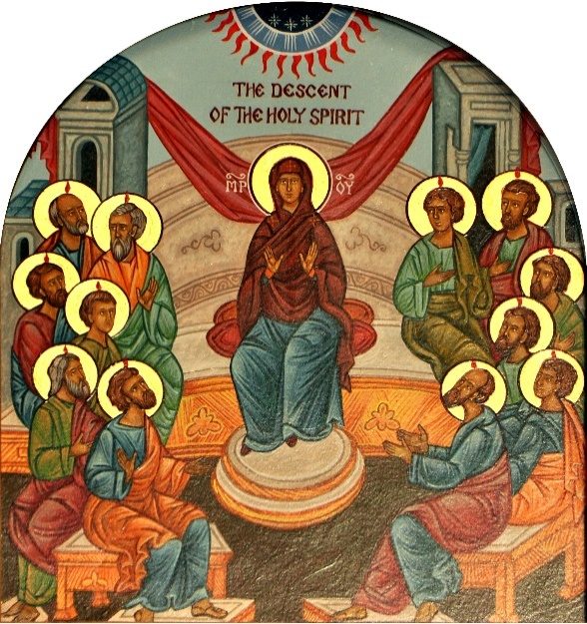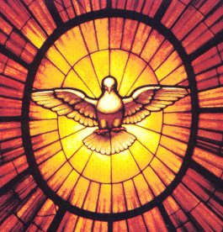

https://en.wikipedia.org/wiki/Seven_gifts_of_the_Holy_Spirit

https://commons.wikimedia.org/wiki/File:The_Descent_Of_The_Holy_Spirit.png

Ruah, Spirit of Fire that cannot be quenched

Animate and inspire us!

Qualify our ambitions

Endorse our attitudes

Bless our actions.

Ruah, Spirit of Fire

Inflame and inspire us to promote

the Reign of God.

And may God, the Source of All Being,

Jesus the Eternal Word

And Ruah, Spirit whose fire cannot be quenched

Bless us now and forever.

We end as we began:

Ki to ingoa O te Matua

O te Tamaiti O te Wairua Tapu

Amene.

*Time to share a cup of tea / coffee and something to eat. Please join us for this.*