Let’s learn about some Saints of the Reformation:

(Search Youtube for “Aotearoa Catholic Luther” for clips on these saints.)

St Thomas More.

“I die the king’s faithful servant, but God’s first.”

With these now famous words, Sir Thomas More surrendered his earthly life and accepted martyrdom. This brave man went from the high-ranking position of Lord High Chancellor of England to imprisonment in the Tower of London in just a matter of years. What happened?

Thomas was an intelligent man who studied law. As his political career advanced, he earned a very good reputation for himself. People like and respected him, including King Henry VIII. He was very successful in his new role as adviser to the king. This position gave him many responsibilities, but before long, Thomas found that he could no longer support the king without being unfaithful to the teachings of the Church.

He took a stand, refusing to acknowledge both the king’s divorce and his desire to be head of the Church in England. This earned him imprisonment in the Tower of London and the crown of martyrdom. He was martyred just a few weeks after his friend [St. John Fisher](http://www.catholicplayground.com/saint-john-fisher-coloring-page-june-22nd/), who died for the same reason. The two men were canonized 400 years later by Pope Pius XI.

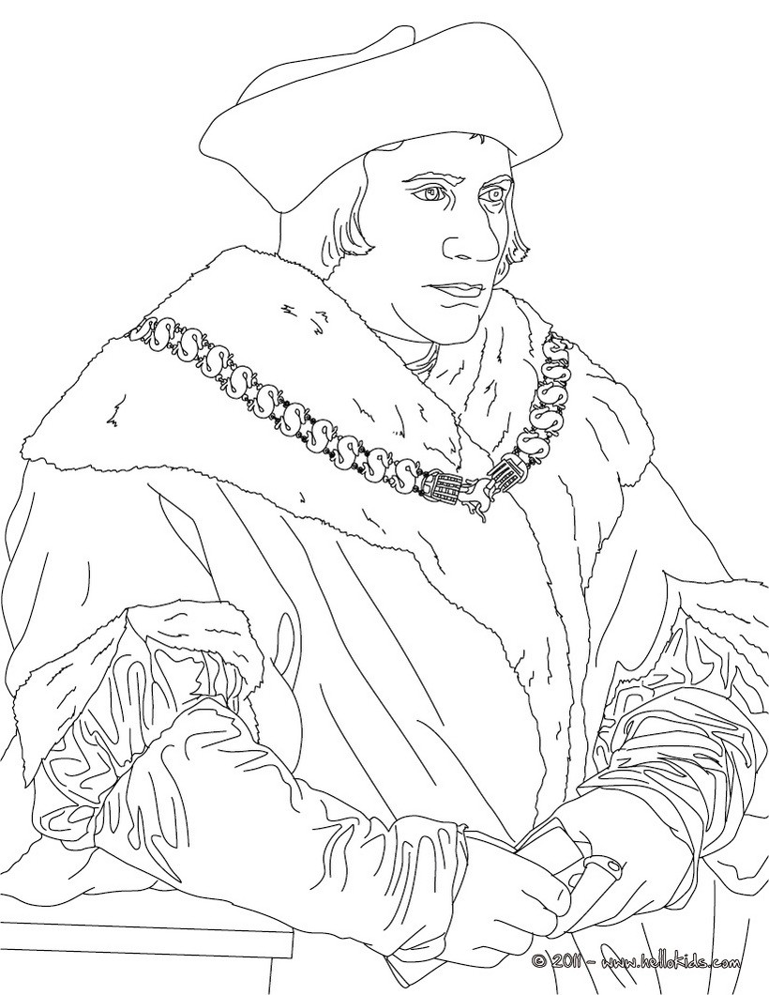

St John Fisher:

During his lifetime, John was a scholar, teacher, priest, bishop, chancellor, and martyr.  He is most known for his conflicts with King Henry VIII, who made plans to divorce his wife, Catherine. John was close to Catherine and gave her advice, speaking out strongly against the divorce. He faithfully believed that marriage is a sacrament, which is holy and cannot be dissolved. When Pope Clement VII refused to annul the king’s marriage, the king took matters into his own hands. Henry made himself head of the Church in England and declared his marriage annulled. However, John stood with the Church and refused to acknowledge these actions as legitimate. By order of the king, John was promptly sent to the Tower of London and condemned to death. He was beheaded on June 22, 1535.  John was friends with Thomas More, who was martyred the same year for also refusing to acknowledge the king’s divorce. The two saints were canonized together just 400 years later by Pope Pius XI.

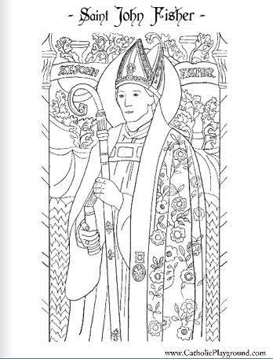

St Ignatius Loyola: Founder of the Society of Jesus, known as the Jesuits.

Saint Ignatius of Loyola (October 23, 1491- July 31, 1556) was a Spanish Basque priest and theologian, who founded the religious order called the Society of Jesus (Jesuits) and became its first Superior General. The Jesuit order served the Pope as missionaries, and they were bound by a vow of special obedience to the sovereign pontiff in regard to the missions. They therefore emerged as an important force during the time of the Counter-Reformation.

Ignatius is remembered as a talented spiritual director. He recorded his method in a celebrated treatise called the Spiritual Exercises, a simple set of meditations, prayers, and other mental exercises, first published in 1548.

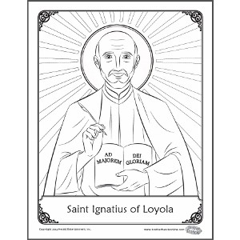

St Teresa of Avila in Spain 1515-1582

As a young girl, Teresa of Avila led somewhat of a wild life. By the time she reached 16, her father intervened and Teresa was sent to a convent. At first, many sins got in the way of her spiritual life. But over time, she transformed into a woman who deeply loved God and religious life. She spent much of her life learning about and practicing mental prayer. Teresa wrote several books which discussed struggles with prayer life and the power of mental prayer.

Later in life, she dedicated much time to reforming the Carmelite order to which she belonged. With [, she also co-founded the Discalced Carmelites. In 1970, she became one of two women to be named Doctor of the Church.](http://www.catholicplayground.com/saint-john-of-the-cross-coloring/)

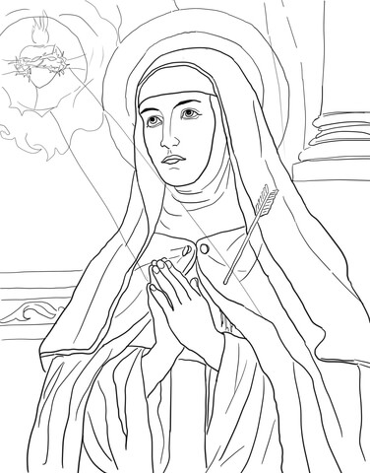

**St Charles Borromeo**

Charles belonged to a very wealthy and influential Italian family. When he was in his 20s, his uncle became Pope Pius IV. He requested that Charles come to Rome, where he stayed for several years, working closely with his uncle. It is said that Charles was also responsible for having Pius reconvene the Council of Trent in 1562.

Despite his father’s death and the high status his family name carried, Charles longed for the priesthood. He was ordained in 1563. At Trent, he initiated great reforms, part of which included developing the Tridentine Catechism. He spent his priesthood implementing ways to strengthen and educate the clergy. He was also active in drawing lapsed Catholics back to the Church, assisting the poor and needy, and establishing seminaries.

When Charles’ brother died suddenly, his family desired that he quit the priesthood and return home to marry, thus carrying on the family name. He, however, had received his call from God. He remained a priest until his death and was canonized in 1610.

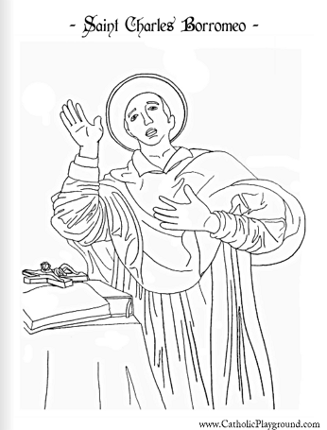

St John of the Cross:

Saint John was born in 1542 and entered the Carmelites at age 22.  He was captured and tortured by members of his own order when he helped [Saint Teresa of Avila](http://www.catholicplayground.com/saint-teresa-avila-coloring-page-october-15th/) reform the Carmelite order. Throughout his life, he wrote several books, which we still have today. Saint John is now a Doctor of the Church and is the patron saint of contemplatives and the contemplative life.

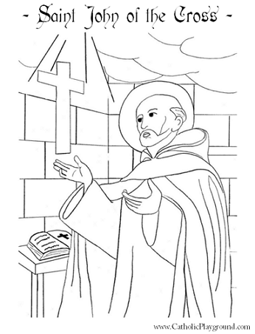

St Francis de Sales: 1567 -1622

Saint Francis knew he had a calling to the priesthood for thirteen years before he told his family. He is said to have converted over 40,000 people to Catholicism during his life. He is known for his book on spiritual direction called Introduction to the Devout Life, which we still have today. He is the patron saint of the deaf as well as Catholic writers and the Catholic press.

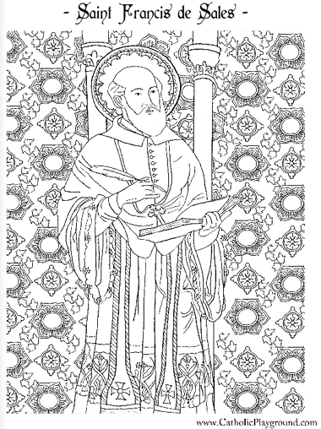

NCRS 2017