The monks England couldn’t break by [James Kelly](http://www.catholicherald.co.uk/author/james-kelly/) posted Wednesday, 4 Oct 17

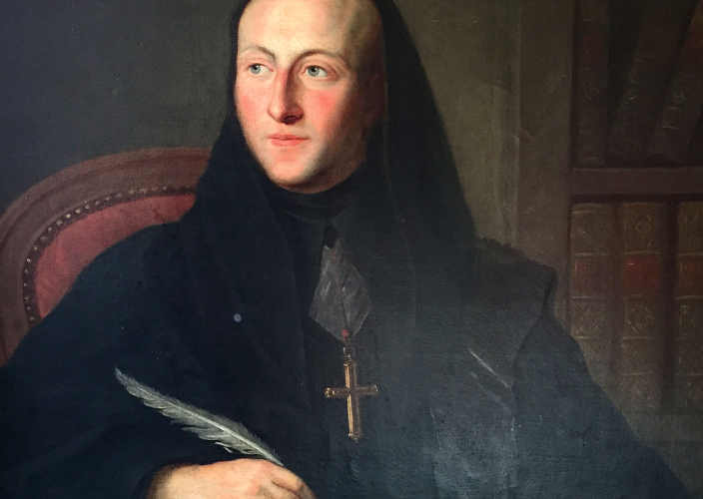 *Charles Walmesley was a Fellow of the Royal Society, despite a life of exile (Property of Downside Abbey General Trust)*

*To the Protestant establishment’s fury, exiled Benedictines kept popping up at crucial moments in history*

A strange sight greeted those assembled at Tyburn one January morning in 1601. The executions of two Catholic priests – Mark Barkworth and the Jesuit, Roger Filcock – and one Catholic lay woman, Anne Line, were set to provide the day’s spectacle.

First to be hanged was Anne Line, who had been sentenced to death for assisting Catholic clergy. Having watched her fate, Barkworth stepped forward, fully conscious of the butchery that awaited him for the treason of having been ordained a Catholic priest in mainland Europe.

However, the gathered throng must have been momentarily taken aback, for Barkworth had somehow procured a Benedictine habit and was tonsured. Such an attire had not been worn in England since before Elizabeth I had ascended the throne more than 40 years earlier but there, before the mob, stood a Benedictine monk.

Any hesitation caused by such a spectacle was not enough to save Barkworth – in fact, some cruel wretch even shouldered the monk’s body weight during his hanging to ensure that he was fully conscious for the subsequent drawing and quartering. Yet Barkworth’s death marked the start of an English Benedictine presence that remains to this day.

Barkworth himself had been trained as a priest at the English College, Valladolid, but, on his way to England as a missionary, he had been received as a novice at the Benedictine monastery of Santa Maria in Irache, and was told he would die a martyr, in the Benedictine habit. Many of the first wave of Englishmen to become Benedictines after the Reformation similarly entered the religious life in Spain, while another sizeable body entered the Cassinese congregation in Italy. What both groupings had in common was that they received permission to return to England as missionaries.

The significance of what they represented was not lost on them: as several monks testified at their martyrdoms, they were from the same order as the first missionary to England, St Augustine of Canterbury, “from whom,” as George Gervase, executed in 1608, put it, “England acknowledged that she had received the Christian faith”.

Like the other missionary clergy who had been secretly entering England since the 1570s, these missionary monks brought with them the Catholic Reformation. Imbued with the zeal of a movement then sweeping Catholic Europe and, increasingly, far-flung parts of the globe from Asia to America, they were agents for the transfer of religious and intellectual ideas gaining ground in mainland Europe.

But nor were they solely about the new: they also tracked down the last surviving monk of Westminster Abbey. By the start of the 17th century, the infirm Sigebert Buckley lived under a form of house arrest. In 1607, he aggregated two of the new monks to him, thereby ensuring the continuity of the English Benedictines from the medieval period. As the new monastic movement grew and the monks re-founded the English Benedictine Congregation in 1619, this symbolic act took on greater significance.

It meant that the English Benedictines of the 17th century could lay claim to the old monastic properties which the Order had once enjoyed. As such, the English Benedictines throughout the period elected priors of, for example, Durham, Canterbury and Ely cathedrals, ready for the moment when England – as they believed, inevitably – returned to the Catholic faith.

This did not stop the monks forming new houses in exile, three of which remain to this day. St Gregory’s, founded at Douai in northern France in 1606, is now better known as Downside Abbey; St Laurence’s, founded in the town of Dieulouard in Lorraine in 1608, is now Ampleforth Abbey; St Edmund’s, Paris, founded in 1616, is now settled at Woolhampton, Berkshire, as Douai Abbey.

Perhaps the grandest of the monastic foundations in exile, the Abbey of Ss Adrian and Denis, situated in the small town of Lamspringe, near Hildesheim in Lower Saxony from 1643, has no surviving successor. Its church was purportedly one of the best examples of baroque architecture in that region, emphasising the monks’ commitment to the Catholic Reformation.

Unusually, these houses had few resident monks, the majority of their membership working on the English mission. Yet proscription and exile did not stop the monks’ involvement in the nation’s history. For example, John Huddleston is believed to have sheltered the future Charles II in 1651 during his escape from parliamentarian forces who had recently executed his father, King Charles I. Huddleston afterwards became a monk and, on his return to England, resided at Somerset House, serving as chaplain to Henrietta Maria (Charles I’s wife), then Catherine Braganza (Charles II’s wife). Purportedly, he received Charles II into the Catholic Church on his deathbed.

In other words, these monks, despite their official proscription, were in and around at vital moments in the nation’s narrative. Their story is not just of Catholic importance but also provides a more vivid and accurate account of England’s history.

*James Kelly is Sweeting Fellow in the History of Catholicism at Durham University and principal investigator of the Arts and Humanities Research Council-funded Monks in Motion project*

Retrieved 05/10/17 from: http://www.catholicherald.co.uk/commentandblogs/2017/10/04/the-monks-england-couldnt-break/