Overview of likely climate change impacts in New Zealand

This page provides an overview of likely climate change impacts in New Zealand. It links to information that local government can use to prepare its response to climate change.

What changes can we expect to our climate?

In New Zealand, changes in climate – such as temperature and rainfall – are already occurring. These changes will occur to differing extents in different parts of New Zealand throughout this century and beyond.

Based on the latest climate projections for New Zealand, by the end of this century we are likely to experience:

* higher temperatures – greater increases in the North Island than the South, with the greatest warming in the northeast (although the amount of warming in New Zealand is likely to be lower than the global average)
* rising sea levels
* more frequent extreme weather events – such as droughts (especially in the east of New Zealand) and floods
* a change in rainfall patterns – with increased summer rainfall in the north and east of the North Island and increased winter rainfall in many parts of the South Island.

Annual average temperature changes by 2090

Under a low emissions scenario (left) and a high emissions scenario (right) compared to the 1995 baseline

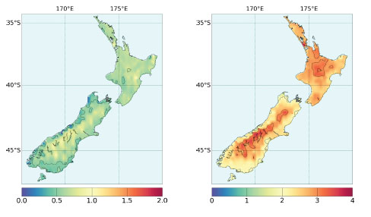

Annual average rainfall changes by 2090

Under a low emissions scenario (left) and a high emissions scenario (right) compared to the 1995 baseline

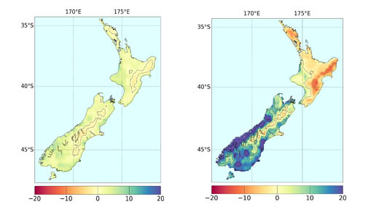

Impacts of climate change

| **ISSUE** | **LIKELY IMPACTS** |
| --- | --- |
| Higher temperatures | * There is likely to be an increase in demand for air-conditioning systems and therefore electricity in summer. * People are likely to enjoy the benefits of warmer winters with fewer frosts, but hotter summers will bring increased risks of heat stress and subtropical diseases. * There may be a reduction in demand for winter heating meaning lower costs and reduced stress on those who cannot afford electricity. |
| Flooding | * More frequent intense winter rainfalls are expected to increase the likelihood of rivers flooding and flash flooding when urban drainage systems become overwhelmed. |
| Water resources | * Water demand will be heightened during hot, dry summers. * Longer summers with higher temperatures and lower rainfall will reduce soil moisture and groundwater supplies. * Drought intensity will likely increase over time. Drier conditions in some areas are likely to be coupled with more frequent droughts. * River flows are likely to be lower in summer and higher in winter. * Lower river flows in summer will raise water temperatures and aggravate water quality problems (eg, through increased algae growth). |
| Sea-level rise | * Rising sea levels will increase the risk of erosion, inundation and saltwater intrusion, increasing the need for coastal protection. |
| Health | * Higher levels of human mortality related to summer heat are expected.   Higher winter temperatures may lead to a reduction in winter related human mortality and illnesses such as colds and flu. |
| Biodiversity | * Warmer temperatures will alter habitats that are critical to some species, increasing the risk of localised extinction. * Warmer temperatures will favour conditions for many exotic species as well as the spread of disease and pests, affecting both fauna and flora. * Increased summer drought will put stress onto dry lowland forests. * Earlier springs and longer frost-free seasons could affect the timing of bird egg-laying and the emergence, first flowering and health of leafing or flowering plants. |
| Built environment | * Increased temperatures may reduce comfort of occupants in domestic, commercial and public buildings and could lead to disruptions to business. |
| Transport | * Hotter summers may damage elements of transport infrastructure causing buckled railway lines and damaged roads, with associated disruption and repair costs. |
| Agriculture | * Agricultural productivity is expected to increase in some areas but there are risks of drought and spreading of pests and diseases. * There are likely to be costs associated with changing land-use activities to suit a new climate. |
| Business and Finance | * Households may find it more difficult to access adequate insurance cover in the face of increased flood risk. * Fruit and vegetable growers may find it more expensive to insure against weather related damage (eg, from hail). * The risk management of potential climate change impacts may provide significant opportunities for businesses. |

Retrieved 15/03/18 from: <http://www.mfe.govt.nz/climate-change/likely-impacts-of-climate-change/overview-of-likely-climate-change-impacts>